1. **Student Details**

Full Name: Muhammad Asnawi Iman bin Yusof

Student ID: 21FTT1248

Group Code: DISS07

PB Email: [21ftt1248@student.pb.edu.bn](mailto:21ftt1248@student.pb.edu.bn)

1. **Website URL:**

<https://21ftt1248.github.io/eportfolio/>

1. **Screenshot of Website Pages**

GitHub:

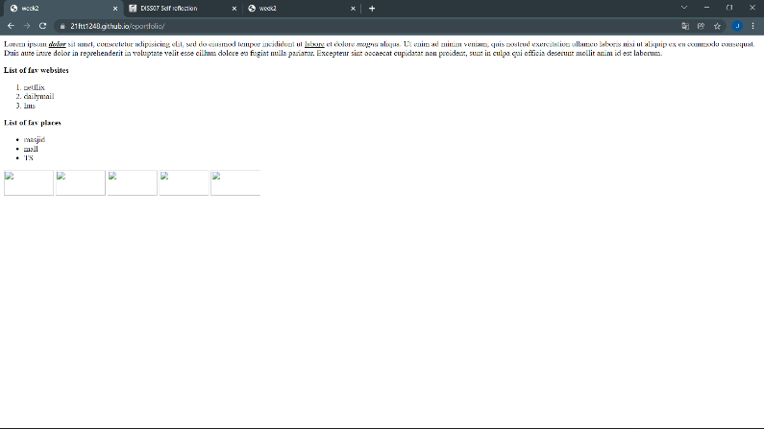

Sublime Text 3:

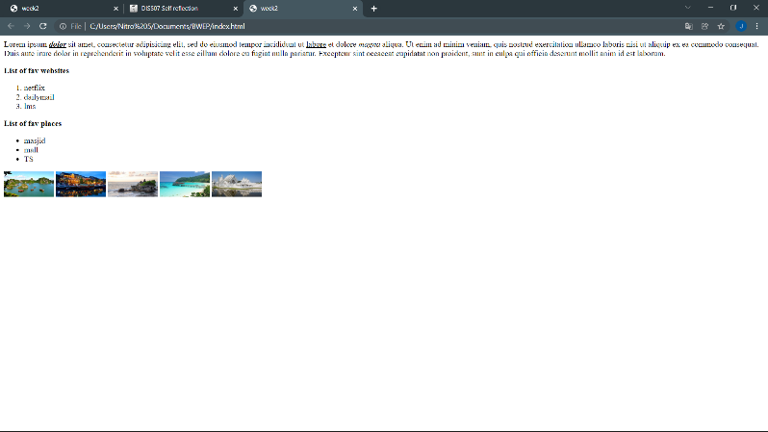

1. **Self-reflections**

What I have learnt from this task is in practical which I learnt from Sir Khalid is to create a web page using text-editor with sublime text 3 and using GitHub to create the website (upload there).

With the use of Sublime text 3, I learnt the functions of HTML5 basic structure which the html is the language attribute which declares what language the page content is in whereas html is in English. The head acts as the introduction which usually includes the title, link, script and meta. As for the body is the contents of the web page.

I also learnt the html text formatting which using the block element with one of them is paragraphing in order to force a break between the enclosed text and the text surrounding it. Other than that, I learnt using text style tags on how to make the text **bold**, underlined, *italic* and so on. The formatting includes i.e. <p> - opening </p> - closing: <p> </p> (for paragraph) with just simply put the element and press tab. Besides that, is the HTML list that is used to group set of items in a webpage which I learnt to use ordered list and unordered list. Lastly, how to upload image and making sure the image appeared on the web page because the image would not appear if you can not locate where the image is and give the specific details. In order for the image to appear in the webpage, you need to find where the image is located, state it specifically as is it in the folder in another folder? The file names? The file types? Also, how to change size of the images using width and height.